Focused Ultrasound Stimulation (FUS) is a non-invasive neuromodulation technique that utilizes focused ultrasound waves to precisely target and stimulate specific tissues. This makes this technology very useful for the treatment of CNS regions as it is capable of reaching deep brain structures, the brainstem, and the spinal cord Di Biase et al. (2019). Unlike traditional neuromodulation methods, such as transcranial magnetic stimulation (TMS) or deep brain stimulation (DBS), FUS offers the distinct advantage of spatial precision without the need for surgical intervention. This precision is achieved by directing highly focused ultrasound beams toward a targeted area, where the energy delivered can be modulated to influence neural activity. The non-invasive nature of FUS enables real-time adjustments, providing a versatile platform for customized therapy and research (Lee et al., 2024).

A subset of FUS, Low-Intensity Focused Ultrasound (LIFUS), is a technique that operates at low energy levels compared to conventional therapeutic techniques (Arulpragasam et al). LIFUS utilizes sound waves that are below the safety thresholds established by regulatory bodies like the FDA for imaging ultrasound, ensuring that the technique is safe to use. At these low energy levels, LIFUS is capable of modulating neural activity without causing thermal damage or disrupting tissue integrity. LIFUS has been shown to influence both the excitability and plasticity of neural circuits, making it an ideal tool for non-invasive neuromodulation. Furthermore, it applies acoustic energy that reversibly modulates neural activity (Blackmore et al.).

The stimulation procedure involves using a fixation mechanism to position the transducer in place over the rodent's head. Acoustic gel is applied between the skin and the surface of the transducer to improve acoustic transmission. The pressure at the output is calibrated using a hydrophone to ensure (Precision Acoustics, UK).

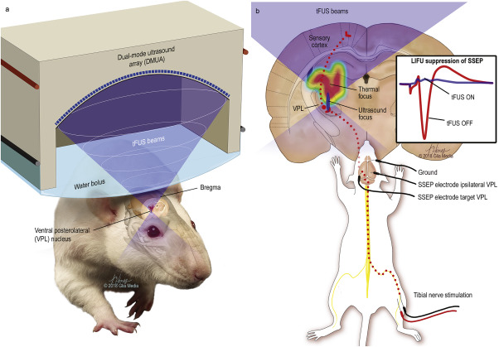

Figure 1: Illustration of the delivery of transcranial-focused ultrasound to the ventral posterolateral nucleus of the thalamus with the mechanical focus highlighted in blue (Darrow et al).

Arulpragasam, A. R., van't Wout-Frank, M., Barredo, J., Faucher, C. R., Greenberg, B. D., & Philip, N. S. (2022). Low intensity focused ultrasound for non-invasive and reversible deep brain neuromodulation—a paradigm shift in psychiatric research. *Frontiers in Psychiatry*, *13*, 825802.

Blackmore, J., Shrivastava, S., Sallet, J., Butler, C. R., & Cleveland, R. O. (2019). Ultrasound neuromodulation: a review of results, mechanisms and safety. *Ultrasound in medicine & biology*, *45*(7), 1509-1536.

Darrow, D. P., O'Brien, P., Richner, T. J., Netoff, T. I., & Ebbini, E. S. (2019). Reversible neuroinhibition by focused ultrasound is mediated by a thermal mechanism. *Brain stimulation*, *12*(6), 1439-1447.

Di Biase, L., Falato, E., and Di Lazzaro, V. (2019). Transcranial focused ultrasound (tfus) and transcranial unfocused ultrasound (tus) neuromodulation: from theoretical principles to stimulation practices. Frontiers in neurology, 10:549.